

Is a state’s cesarean delivery (CD) rate effected by a state’s median income? No, Florida and Utah have the same median household income, but their CD rate puts them in 2nd and 48th place out of all states or take New Jersey, 3rd in income, 47th in CD.



$55k

22.7%



$55k

36.9 %



$81k

35.2%

When you look at the US as a whole, race plays no role in the cesarean delivery rate.

A woman’s pre-pregnancy BMI does play quite a role in determining weather she may need a cesarean delivery; this is especially true with a BMI of 30+

Age is the biggest demographic that could determine whether a person might need a cesarean delivery. As age increases, so does the CD percent, all the way to 69.9% for the 50+ age group.

Another factor that could play into the cesarean delivery is who is paying the hospital bill- if a person has private insurance, the CD is 32.1% but if they are uninsured and will be paying the bill themselves the CD is 22.6%.

**<18.5**

Underweight

**21.4%**

**18.5-24.9**

Normal

**25.7 %**

**25-29.9**

Overweight

**32.2 %**

**35-39.9**

Obesity II

**43.5%**

**30-34.9**

Obesity I

**37.8 %**

**>39.9**

Obesity III

**52.3%**

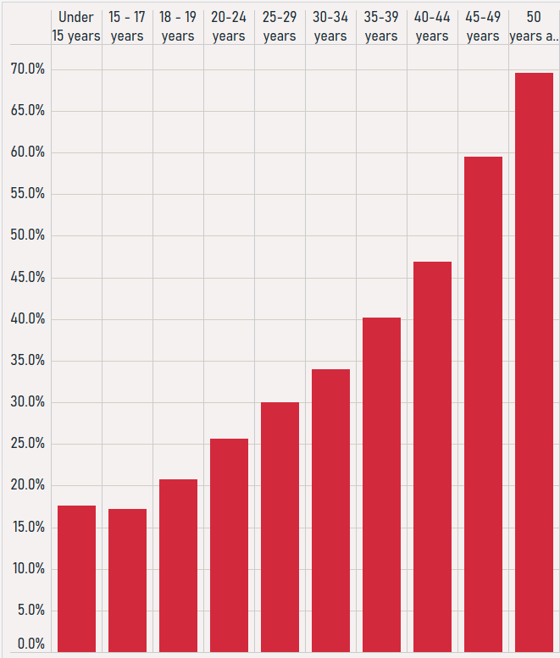

Under 15

15 - 17

18 - 19

20 - 24

25 - 29

30 - 34

35 - 39

40 - 44

45 - 49

Over 50

WHO recommends a country’s cesarean delivery rate to be 10-15%, but the US is at 30.5%

Do Demographics Effect Birth Delivery Method?

Hispanic

31.6%

AIAN

28.5%

Asian

31.4%

Black

31.6%

NHOPI

30.6%

White

30.8%

%%